**Lovely** **Proffesional** University..



**Name**=**Anubhav** **Sharma**

Section=B.Tech,cse,K22SW

RollNo.=70

Subject=CSE326 (Project)

Submitted to=**Ms**. **Navjot** **Kaur**

--Some webpages Of my Restaurant Website Created by me.

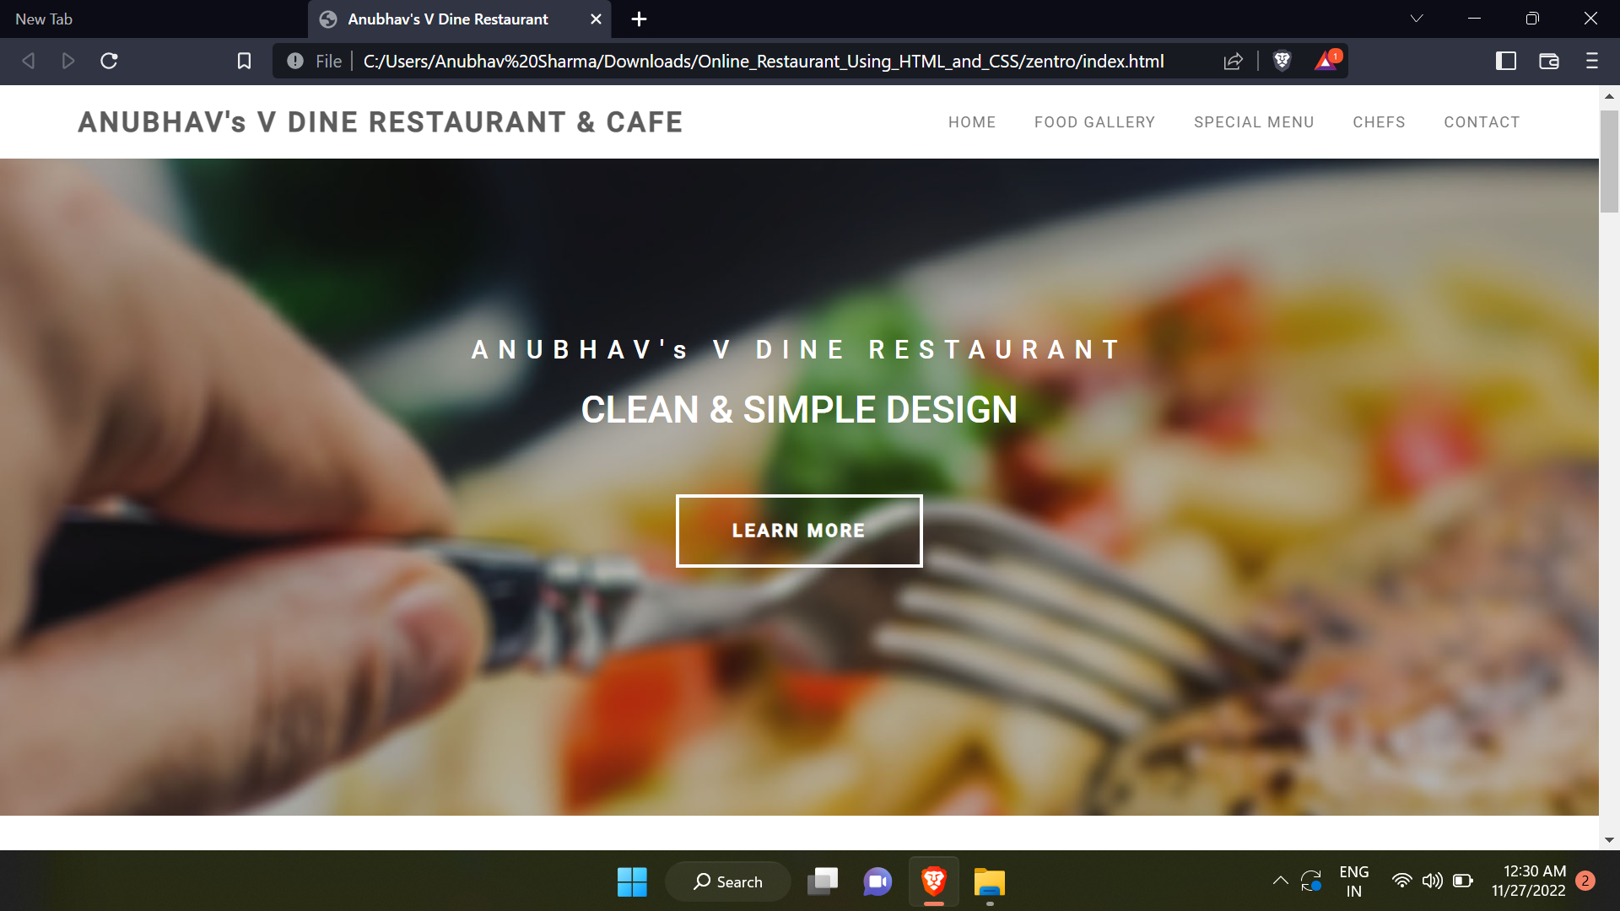

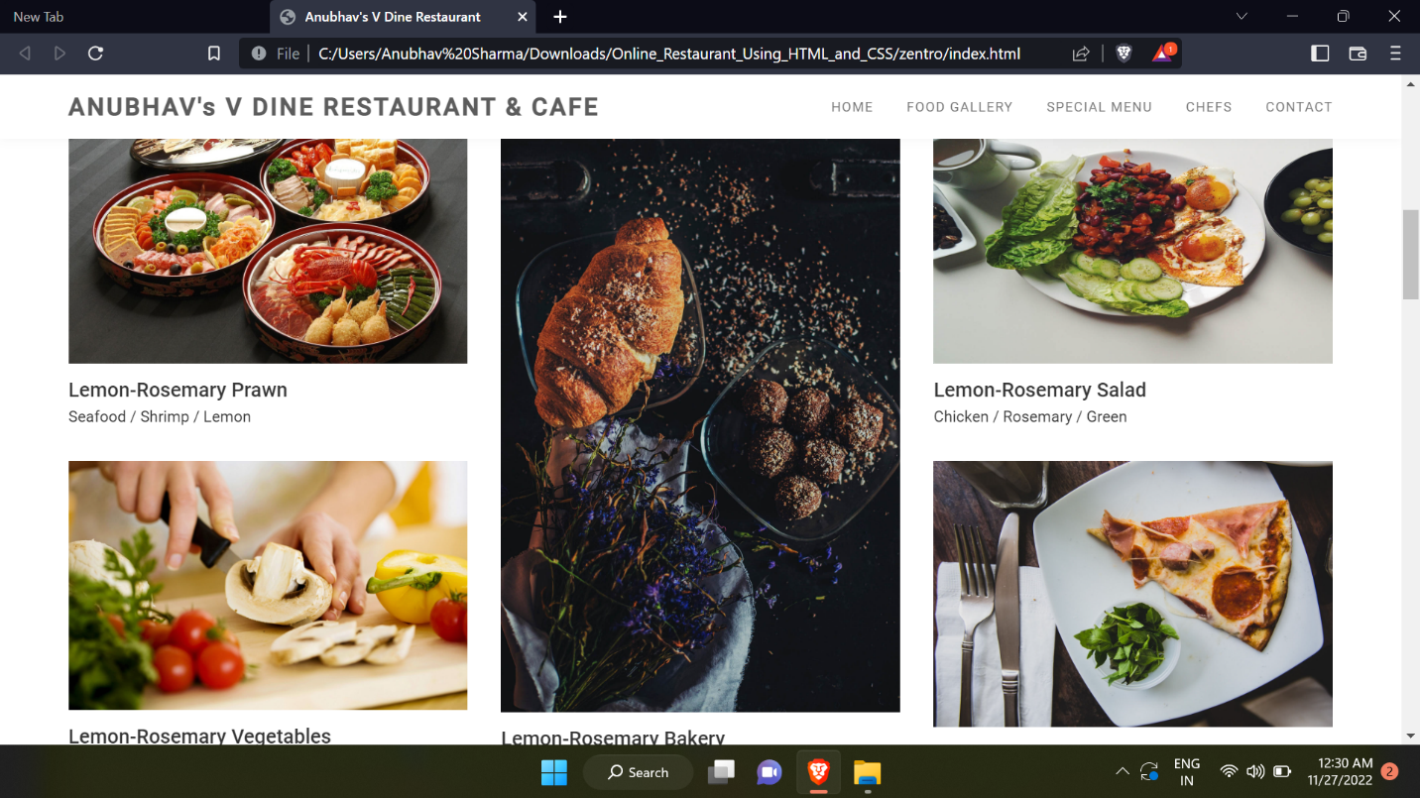

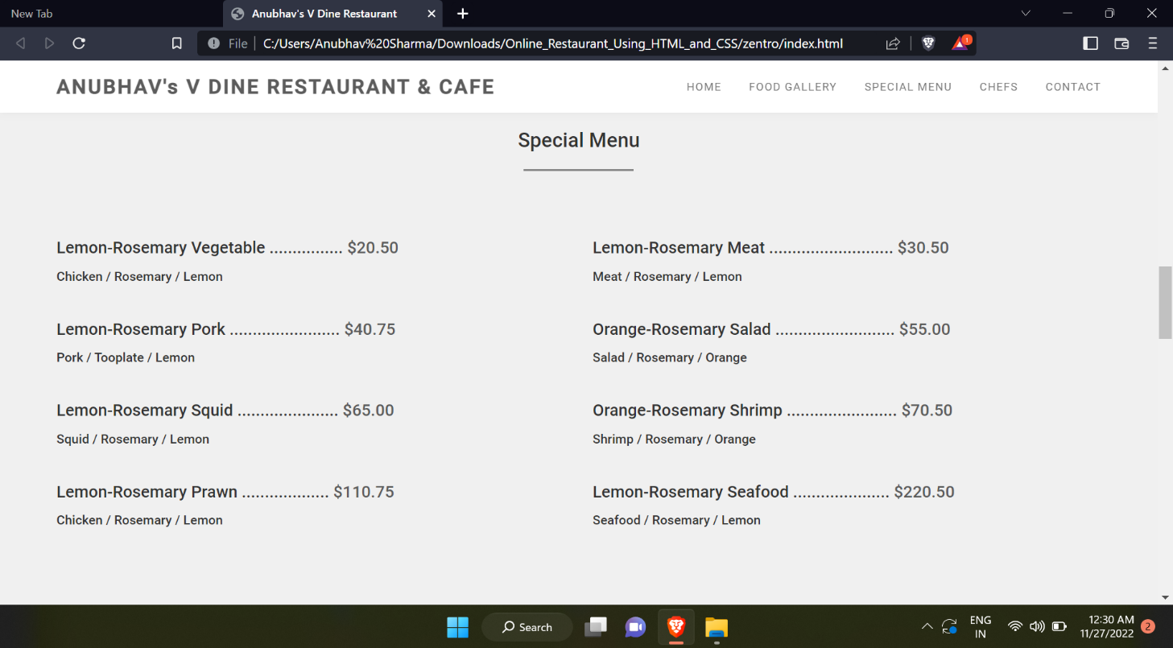

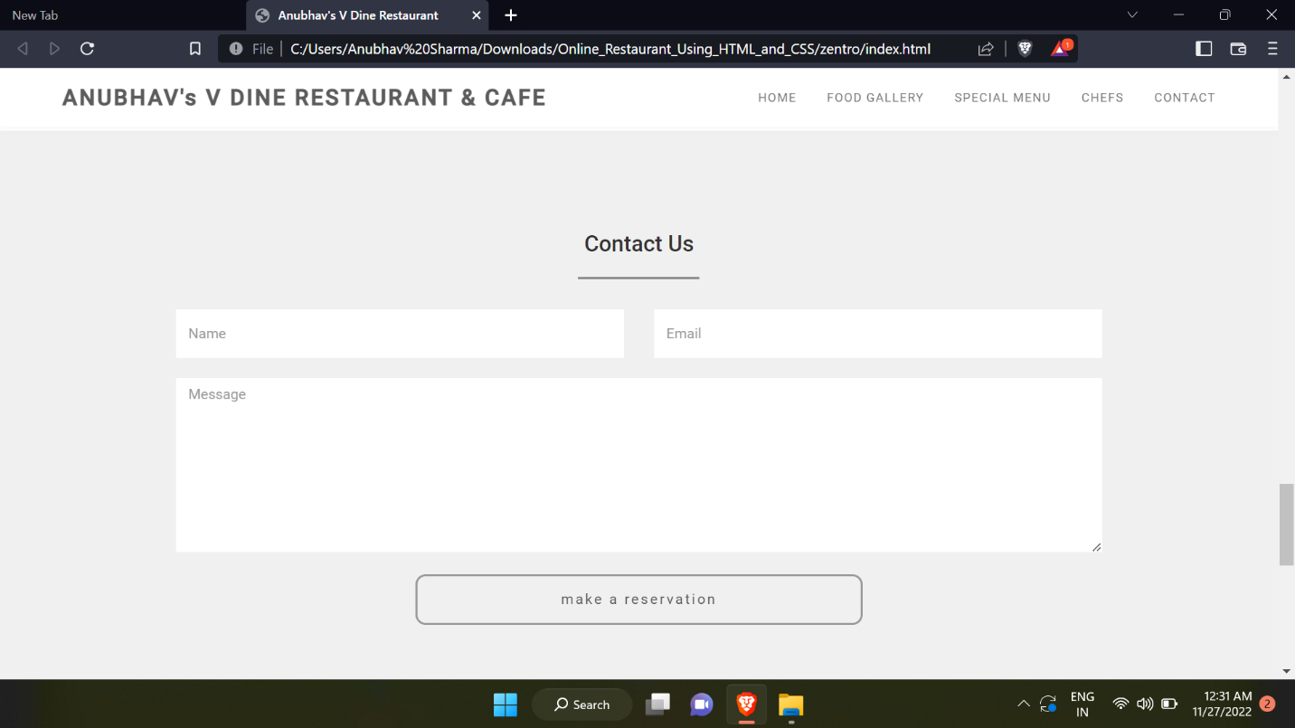

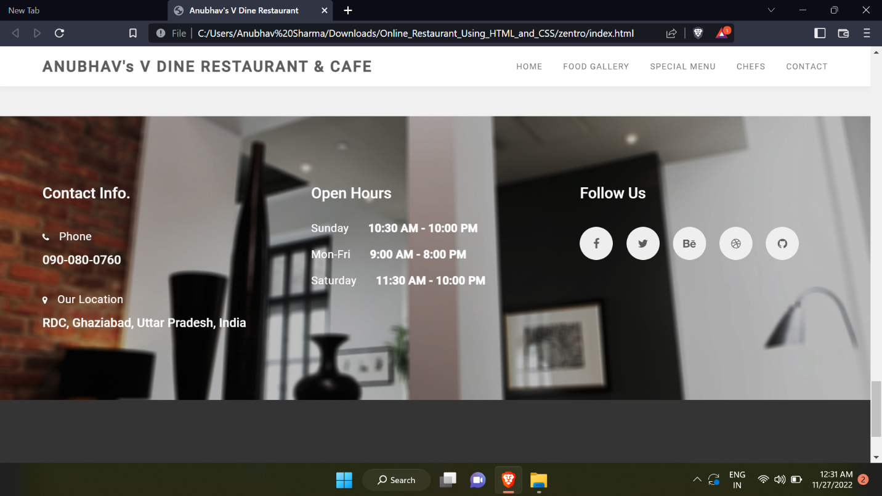

About Project

This project is totally based upon my restaurant’s order system.From here you will get new dishes..this project is designed by using HTML,CSS and JAVASCRIPT..

Their basic elemets are used by me to make these such beautiful webpages..

I create a form here just to contact for any feedback or any query..and for reservation of sitting plan..

This form is just created by using simple<form> </form> tag..and its important elements..

Created By-Anubhav Sharma……